Programming Assignment #2

(for Ch 3)

Problem Description

Write a program that computes the duration of a projectile’s flight and its height above the ground when it reaches the target. As part of your solution, write and call a function that displays instructions to the program user.

DATA REQUIREMENTS

Program Constant
G 32.17 /* gravitational constant */

Program Input
double Theta /* input – angle (radians) of elevation */
double Distance /* input – distance (ft) to target */
double Velocity /* input – projectile velocity (ft/sec) */

Program Output
double Time /* output – time(sec) of flight */
double Height /* output – height at impact */

Relevant Formula

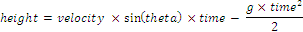

Sample Run

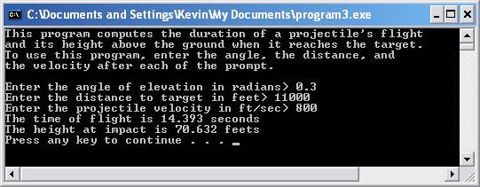

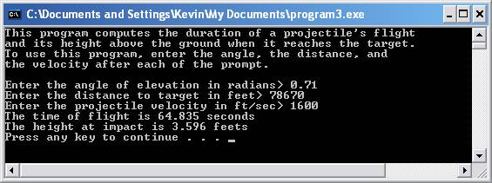

Problem Requirement
a) You must create a file and save it as Program2.c file.
b) The results must be in 3 decimal places.
c) Your program should run correctly with the same inputs and outputs as given in the sample run.

